Project Initialization and Planning Phase

Date | 29 September 2026
Team ID | xxxxxx
Project Name | CRICKSTATS
Maximum Marks | 3 Marks

Define Problem Statements (Customer Problem Statement Template):

As a cricket fan and analyst, I am trying to track player and match performance in a single, consolidated platform. But the current systems are scattered across multiple sources and require manual effort to gather statistics. Because of this lack of integration, I spend too much time compiling data instead of analyzing it. This makes me feel frustrated with the inefficiency, yet hopeful that a unified solution like CRICKSTATS can provide accurate, automated dashboards and help me focus on meaningful insights.
Example:
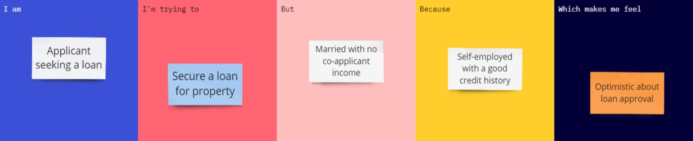

Problem  Statement  (PS) | I am (Customer) | I’m trying  to | But | Because | Which makes me feel
PS-1 | A cricket fan and analyst | Track player and match performance | Current systems are scattered and lack integration | Need consolidated dashboards and automated stats | Frustrated but hopeful for a unified solution

